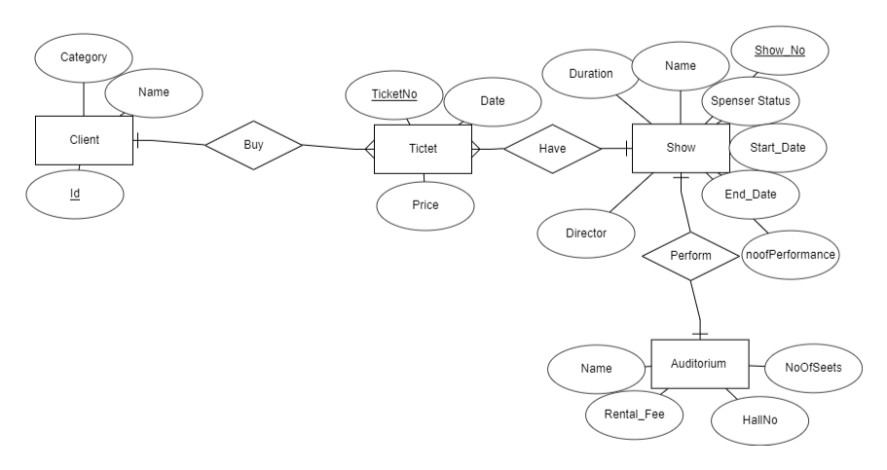
Relational Model:
Auditorium( HallNo., Name, NoOfSeats, Rental_Fee, #Show No)
Show(Show No., Name, noofPerformances, Duration, Start_Date, End_Date, Sponsore Status, Director)
Ticket(TicketNo., Date, Price, #Show No, #Client_Id)
Client(Id, Name, Category)

1NF:
Auditorium( HallNo., Name, NoOfSeats, Rental_Fee, #Show No)
Show(Show No., Name, noofPerformances, Duration, Start_Date, End_Date, Sponsore Status, Director)
Ticket(TicketNo., Date, Price, #Show No, #Client_Id)
Client(Id, Name, Category)

2NF:
Auditorium( HallNo., Name, NoOfSeats, Rental_Fee, #Show No)
Hall(HallNo.,NoOfSeats)
Show(Show No., Name, noofPerformances, Duration, Start_Date, End_Date, Sponsore Status, Director)
Ticket(TicketNo., Date, Price, #Show No, #Client_Id)
Client(Id, Name, Category)

3NF:
Auditorium( HallNo., Name, NoOfSeats, Rental_Fee, #Show No)
Hall(HallNo.,NoOfSeats)
Show(Show No., Name, noofPerformances, Duration, Start_Date, End_Date, Sponsore Status, Director)
Ticket(TicketNo., Date, Price, #Show No, #Client_Id)
Client(Id, Name, Category)

